Boss Level Examples

Here’s a first pass description of eight Truckasaurus-based boss levels.

Boss 1 – Guarding an Object

Location: Evergreen Terrace

The Truckasaurus is guarding an object. You have to lure him around the block, far enough so that you can beat him back to the location, as shown in Figure 1.

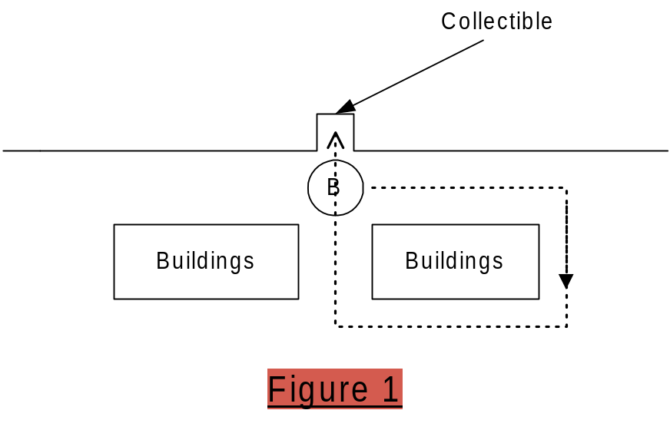

Boss 2 – Through a Maze

Location: Squidport, Krustylu Studios

You lead the Truckasaurus through a simple maze, into a trap (animation & location TBD). Make a wrong turn and you’re toast. The maze area is Krustylu Studios. There will be an animated physics object near the end of the maze that the user has to time right, or they’ll get caught.

Boss 3 – Cage the Truckasaurus

Location: Downtown

Start on-foot. Run to your car, which is pointed the wrong way (i.e., towards Truckasaurus). You have to do a “Rockford” (spin the car at speed) and race down the street. Get out of the car, wait for the Truckasaurus to get “in the zone”, and drop a two-sided gate on him. Miss the timing and he’ll catch you.

Boss 4 – The Homer-saurus

Location: Power Plant, inside the Stadium

In the stadium, control the Truckasaurus with Homer animations, on some kind of rampage mission (TBD).

Boss 5 – Guarding a Place

Location: Squidport

The Truckasaurus is guarding an object at a T-intersection as shown in Figure 2.

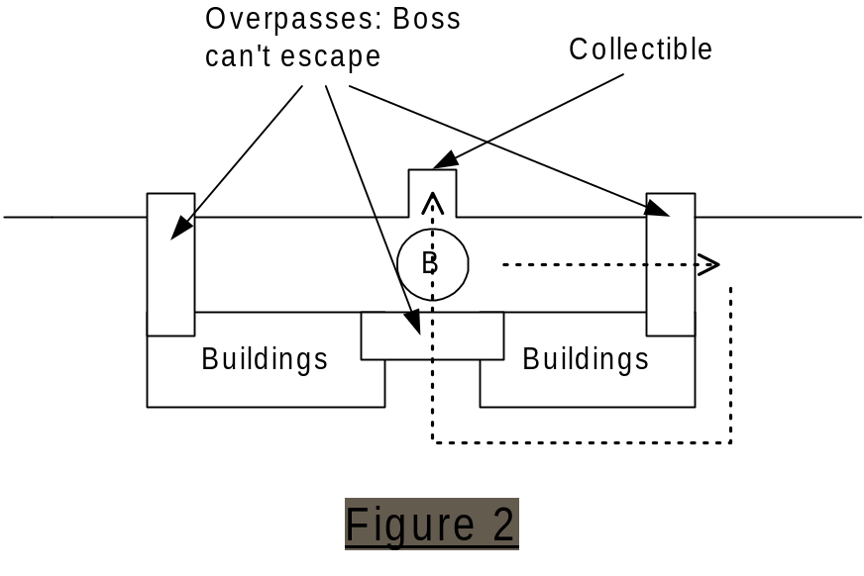
Your objective is to lure him to the end of the block, and then race around the block to get to the collectible object before he gets back there. Overpasses prevent the Truckasaurus from leaving the two streets at the top of Figure 2.

Boss 6 – Cage the Truckasaurus

Location: Downtown

You have to:
- Lure the Truckasaurus to a gate
- Get out and push the button
- Get back to your car before he catches you
- Lure him to the end of the cage, and take an on-foot elevator up to a walkway
- Run to push the door-close button before he escapes

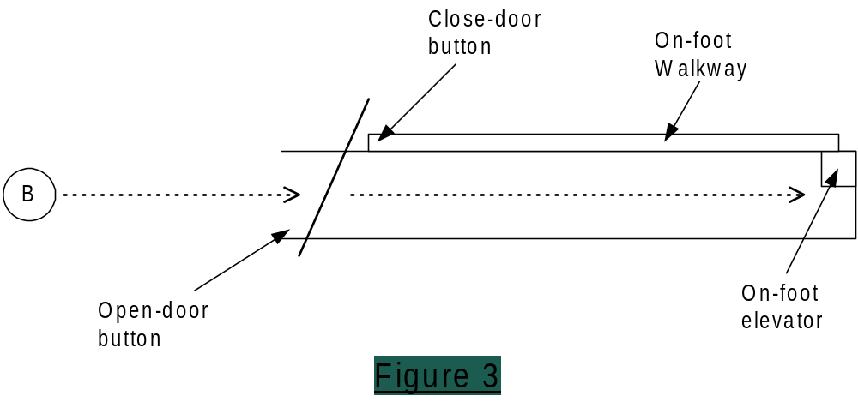

Boss 7 – Through a Maze

Location: Power Plant, train yards

You lead the Truckasaurus through a maze that includes animated physics objects. Lure him into a trap (animation & location TBD). Make a wrong turn and you’re toast. The maze area is the train yards.

Boss 8 – Kill the Truckasaurus

Location: Power Plant, train yards

Inside a stadium, there will be objects (TBD) that allow you to lure the Truckasaurus into a trap, where you’ll get a shot at jumping your car into his head.

Appendix A – Boss Animation

A very smart person suggested that we have just two boss models - Truckasaurus for the regular game and Lardlad for the Halloween level

The only boss character is the Truckasaurus (if we have extra time, we’ll also do LardLad for the Halloween level). Animations we’d need are:

- Mission-start presentation/animation for the boss
  - The same for each mission? Or do we need some mission-specific ones?
- General running and turning
- Chase animations that give feedback on the luring gameplay:
  - Aggressive running (i.e., like in our movie)
  - Getting very close and taking swipes and bites at you
  - Loosing interest if you get too far
- "Guarding" animation (standing and guarding an object)
- Idle animations
- Victory/failure animations, e.g.:
  - He could crush your car in his jaws if he catches you?
  - What if you’re on-foot?
  - What if you get away/win the mission?
- We might have specific animations/NIS for traps:
  - Truckasaurus falling into the water
  - A second trap for boss mission 6?
  - Truckasaurus’ head gets knocked off in final mission?
- A Homer-saurus animation set - the Truckasaurus with Homer animations (i.e., he's in a motion capture suit)
- A Ralph-asaurus animation set - the Truckasaurus with Ralph animations

